Inferring

What is inference and what do we use to infer?
- Use clues and prior knowledge to find out what the author doesn’t tell us
- It is often based on clues about:
- character
- setting
- mood
Why do we infer?
- To deepen our understanding about a text
What makes good inference?
- Justifying our answers with evidence from the text – because/P.E.E.
- Using detail – closely quoting the exact word/phrase
- Finding more than one piece of evidence
- Thinking from the writer’s point of view
I think the writer wanted to make the reader feel empathy for this character early on because her role is so important to the story. Using phrases like ‘the hour her life began’ and ‘sum total of her possessions’ encourages the reader to feel sympathetic towards her because they hint at an empty life before.
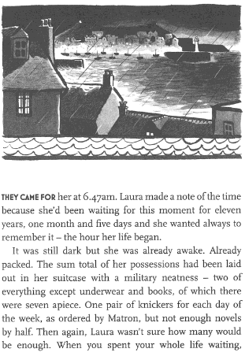
Your turn:
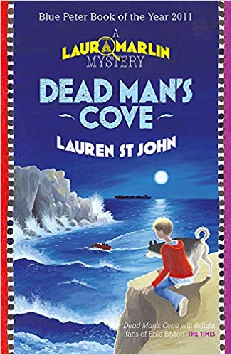
Inferring Stems
- The word * tells me
- The part * tells me
- This makes me think that
- I think this character because
- I think the setting is
- I think the mood is
- I think the writer’s viewpoint is
- I think this character’s viewpoint is

How was Laura feeling?
Where is this text set?

