Asking Questions

Why do we ask questions?
- Asking questions is seeking information
- When we ask questions, we think more deeply about the whole text and we check our understanding as we read

What makes a good question?
- Asking more open ended questions which encourage thinking about the text
- The questions in bold are more likely to be open questions but can also be closed e.g. Why was she feeling sad? (Closed)
- Why do you think Harry acted in that way? (Open)
Why do you think they feel like this? How does the writer create the mood of this text?

Can you think of a true/false question around this part of the text?

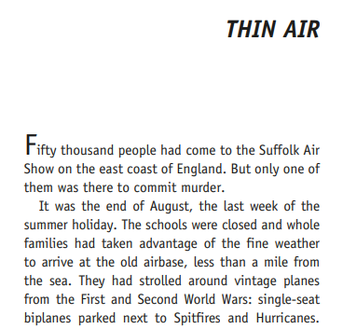
Questioning Stems
- Who
- What
- When
- Where
- I wonder
- Why
- How
- What if
- Why do you think
- How do you think
- How do we know
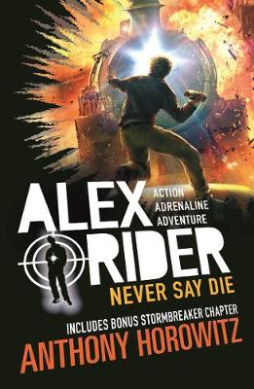
Your turn:

Using one of the asking question stems, what question could you ask?
Can you create a prediction question about what might happen next?

