Learning  Behaviour | Destination Reader  Learning Behaviour stems |  |  | How did we do?
Support and actively listen to others |  |  |  | 1 2 3 4
Use supportive facial expressions – nod, smile, agree. Bring quieter people into conversation look at the speaker, listen and respond to what was said | Support | I like the way you … when you read.  You’ve really improved in…  Which strategy might help you here?  What do you think? |  | 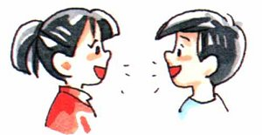  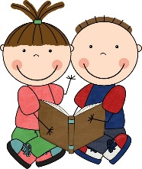
 | Active listening | Good point / idea. Oh yes / no!  I hadn’t thought of that point.  Tell me more about…
Discuss and explain our ideas |  |  |  | 1 2 3 4
Referring back to text and giving extended answers  (Point – Evidence – Explain) | I think this means that … because it says…  My view is that … because in the book ….  Earlier we learnt that … so …  … is similar to ….. because …..  In my opinion …. because ….  This character is ….. because ….. |  |  | 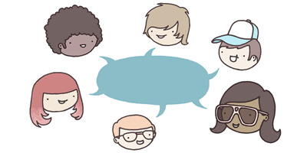
Building on other’s answers | Agreeing |  | I agree with … because …  I’d like to add to that point ….
 | Disagreeing / challenging and offering alternative |  | Alternatively ….  It could be but…….  Why do you think that?
 | New idea |  | Have we considered?  Another point I wish to make is …  On reflection I no longer think that …..
Take responsibility for our own/group’s learning |  |  |  | 1 2 3 4
ensure you took part, made sure everyone understood task and participated | Does anyone feel they need some more explanation?  We worked well today because we …..e.g. made sure we understood each part of the text before we moved on.  We both / all took an equal part in the discussion today.  Today didn’t work well because ….  Our target next time should be to …

Destination Reader
Predicting | Inferring
- I wonder if  - I predict  - I think that ... because  - I think * will happen  - I think I will learn  - The next part will be about | - The word * tells me  - The part * tells me  - This makes me think that  - I think this character … because  - I think the setting is  - I think the mood is  - I think this character feels … because
Asking questions | Clarifying
- Who  - What  - When  - Where  - I wonder  - Why  - How  - What if  - Why do you think  - How do you think | - I think that means  - I didn’t understand  - What does * mean?  - I need to reread this part because  - * is a tricky word so I  - I didn’t understand * so I  - Let’s reread because it didn’t make sense.
Making connections 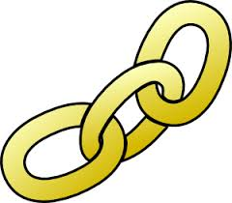 | Summarising
Text to self:  - I know about this because I  - I’ve been to / seen  - I saw a programme about this  - This character reminds me of...  Text to text:  - I think this book is a * (genre) book because  - This reminds me of * because  - This is similar to * because  - This character is similar to * because | - One thing that I remember from that page is...  - Something important that happened was...  - One thing the main character did was...
 | Learning Behaviours
- Support and actively listen to others
- Discuss and explain our ideas
- Take responsibility for your own and your group’s learning.

