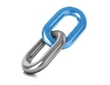
Making Connections

What is making connections?
- Using what we already know from our experiences, other texts and the world

Why do we make connections?
- Engage with our reading and want to read more!
- Understand what we are reading
- Make the text clearer in our mind

What makes a good connection?
- Yourself – you have done something or seen something similar
- Texts – you might have read or felt similar through another story etc.
- World – our wider knowledge of the world e.g. this is because life was difficult in Tudor times…
This reminds me of other books by Michael Morpurgo because of the long, descriptive sentences.

The main character expects his wife to do all the cooking and looking after the baby because it’s set in the 1930s when women’s roles were very different.
This reminds me of other books by Michael Morpurgo because of the long, descriptive sentences

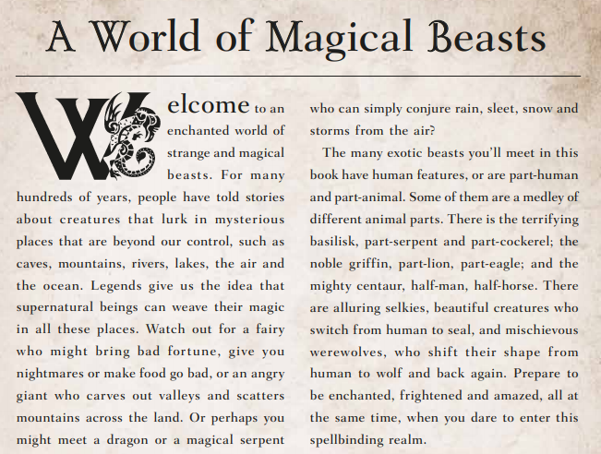
Your turn:
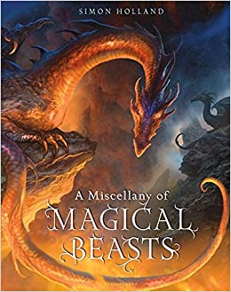
Does this text link to other texts you have read and how?

Making Connections Stems
Text to self:
- I know about this because I
- I’ve been to/seen
- I saw a programme about this
- I can identify with this character because
Text to text:
- I think this book is a * (genre) book because
- This reminds me of * because
- This is similar to * because
- This character is similar to * because
Text to world:
- This links to
- This is because

